CE301 Individual Capstone Project dp19963

**Goals until the next meeting:**

Until my eight meeting with my supervisor I did the following, I started working on my animal minigame.

The minigame is a quiz with images and radio buttons. This is not final as I have only implemented functionality to the game whereas before I focused entirely on the setup and design of the software.

The quiz goes on until you’re done.

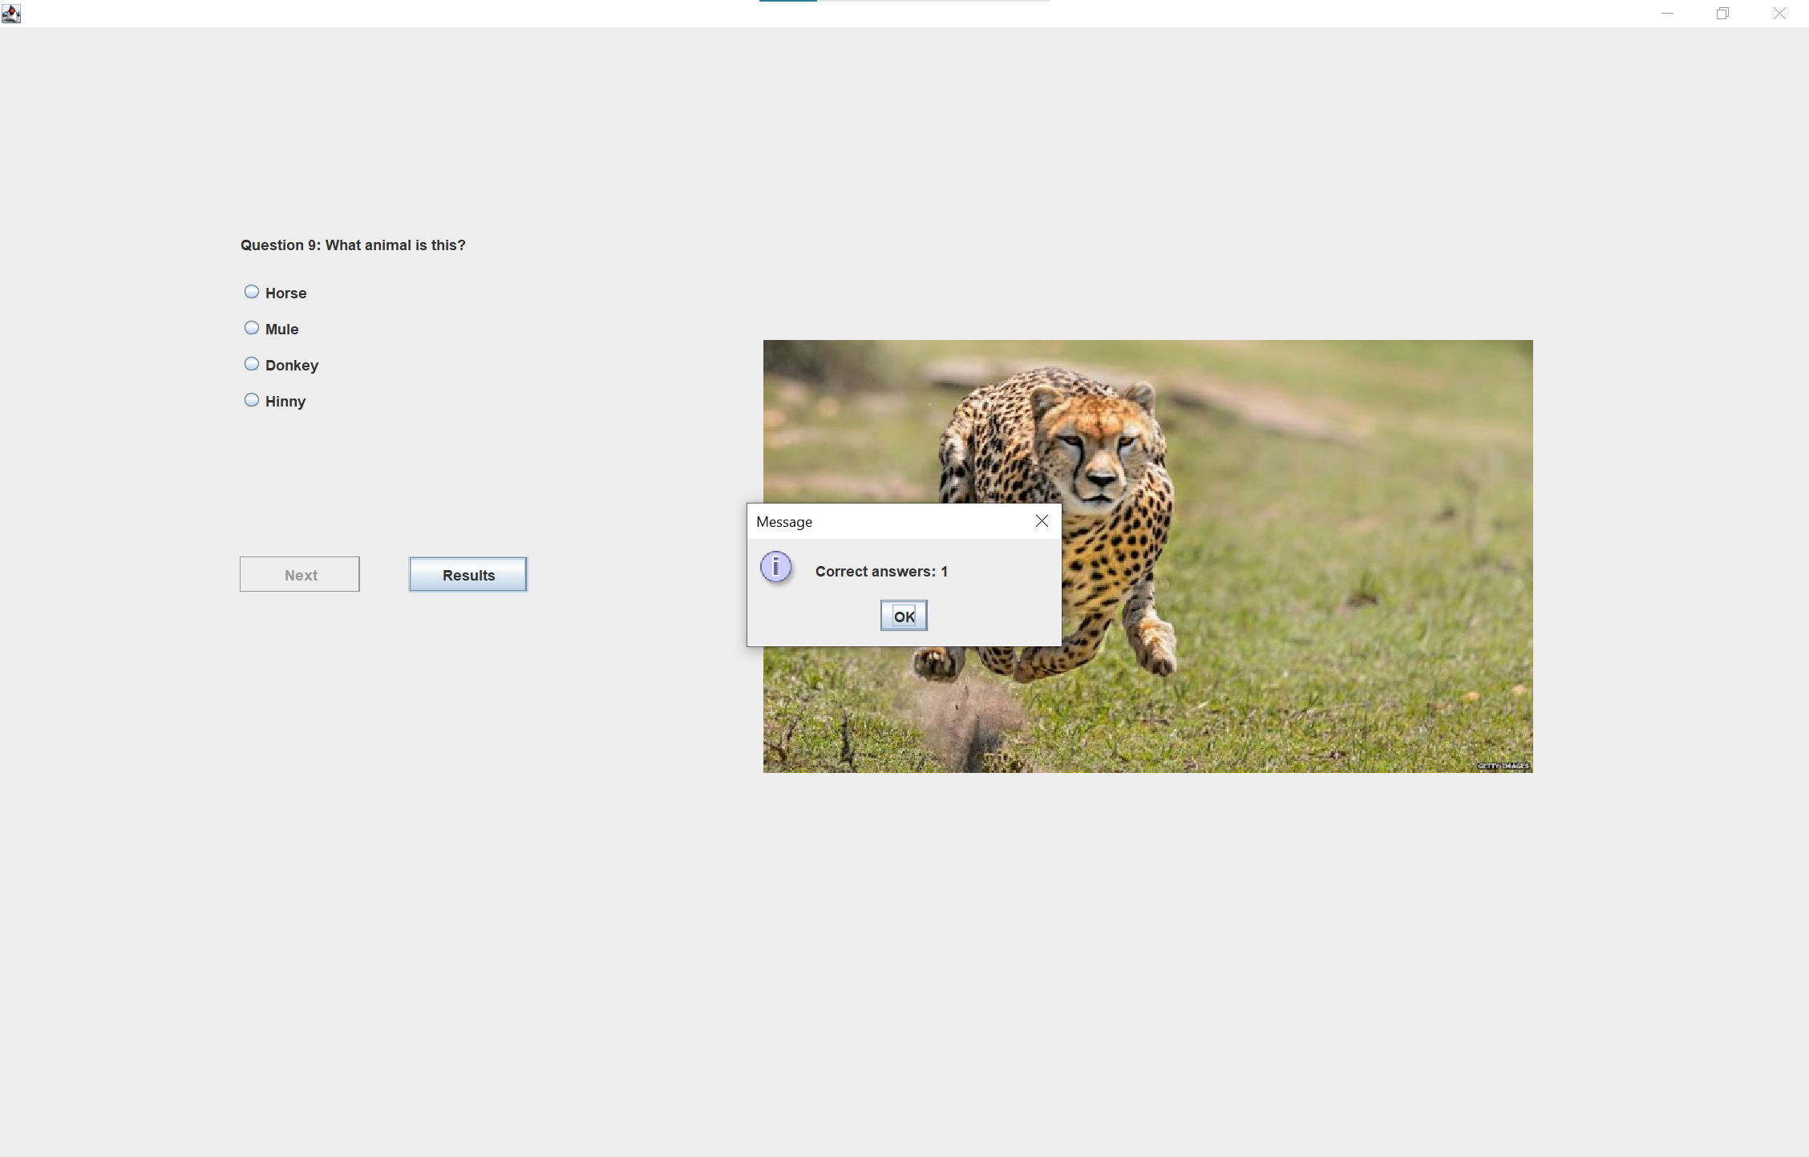

On the last question a result button will appear as you’ll know that you’re done with the quiz and by pressing ‘Results’ you’ll receive amount correct answers.